2-1、RGB LEDs

1. 参考《0-1》文档，插入ESP32模块。
2. 用导线连接IO口与LED控制口，如下图所示：

红色线<------->R LED

绿色线<------->G LED

蓝色线<------->B LED

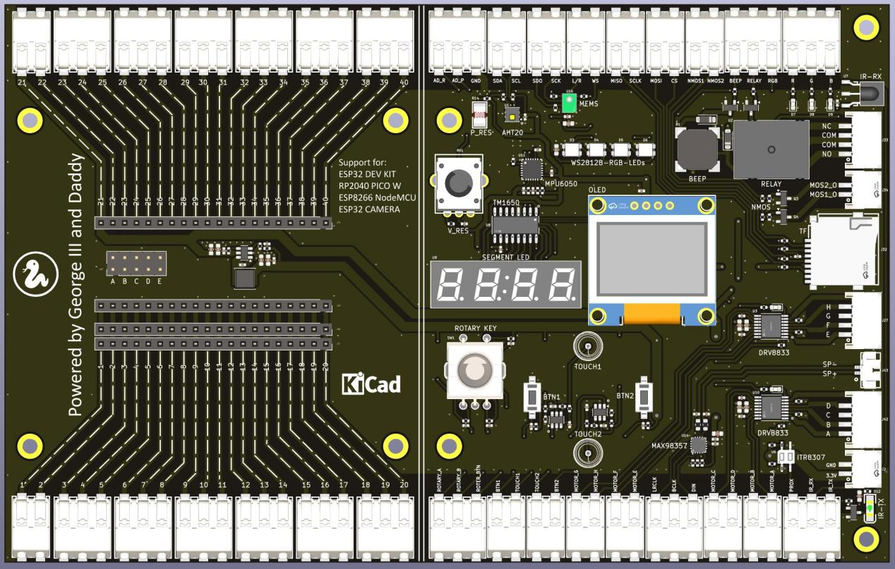

1. 代码示例

#main.py

from machine import RTC,Pin,Timer

import time

# create output pin

R_LED = 27

G_LED = 26

B_LED = 25

led_R = Pin(R_LED, Pin.OUT)

led_G = Pin(G_LED, Pin.OUT)

led_B = Pin(B_LED, Pin.OUT)

def do_led_blink():

# enable internal pull-up resistor

led_R = Pin(R_LED, Pin.OUT, Pin.PULL_UP)

# set pin high on creation

led_R = Pin(R_LED, Pin.OUT, value=1)

# set maximum drive strength

led_R = Pin(R_LED, Pin.OUT, drive=Pin.DRIVE_3)

led_G = Pin(G_LED, Pin.OUT, Pin.PULL_UP)

led_G = Pin(G_LED, Pin.OUT, value=1)

led_G = Pin(G_LED, Pin.OUT, drive=Pin.DRIVE_3)

led_B = Pin(B_LED, Pin.OUT, Pin.PULL_UP)

led_B = Pin(B_LED, Pin.OUT, value=1)

led_B = Pin(B_LED, Pin.OUT, drive=Pin.DRIVE_3)

def do_led_off():

led_R.value(0)

led_G.value(0)

led_B.value(0)

print("do_led_off")

def do_led_on():

led_R.value(1)

led_G.value(1)

led_B.value(1)

print("do_led_on")

while True:

do_led_on()

time.sleep_ms(1000)

do_led_off()

time.sleep_ms(1000)

1. 上传main.py到模块中，按F5或点击运行按钮，就可以看见红、绿、蓝3个颜色的LED每隔1秒闪烁。

